 Information Technology Institute,

Diploma in Artificial Intelligence powered

by EPITA School of Engineering and Computer

Science. APR 2021 - DEC 2021

Efficient Brain Tumor Diagnosis Using Deep Learning with Web API Application

By

**Mohamed Reda Shoaib**

**Mohamed Ahmed Gomaa**

**Nourhan Selim Salem**

**Hesham Hammam Ali**

**Abdulhamid Albendary**

**Amr Salah Abd El-Moteleh**

|  |  |
| --- | --- |
| Information Technology Institute | 2021 |

Acknowledgement

First and foremost, we thank Allah the most gracious and the most merciful for helping me finishing this work.

It is a pleasure to acknowledge my supervisors. we wish to express our sincere thanks to ITI and EPITA. We are deeply indebted to them for valuable supervision, continuous encouragement, useful suggestions, and active help during this work. In addition, we want to thank our friends for their help and support during our work.

Finally, our deepest love and gratitude are devoted to our whole families. We would like to thank our families for their infinite patience and trust. They were usually beside us in all happy as well as hard times. They always encouraged us to move forward and take care of our life, and without the help of them during this period, we would have not finished our project. More words cannot express how much we love and appreciate them. This project is a dedication for them.

Brain Tumour Diagnosis Team

Contents

Contents iii

List of Figures v

List of Tables vii

Chapter 1 Introduction 1

1.1 Artificial Intelligence 3

1.2 Brain tumor 3

Chapter 2 A Literature Review 6

2.1 Introduction 6

2.1.1 Overview of AI Techniques in Healthcare Applications 6

2.1.2 Overview of Some Biomedical Datasets 8

2.2 Related Work to Brain Tumor Diagnosis Methods and Techniques 9

2.3 Summary 14

Chapter 3 Deep Learning for Brain Tumor Detection 16

3.1 Introduction 16

3.2 Proposed Models illustration 17

3.3 The Proposed CNN Models Architecture 17

3.4 Performance Metrics 19

3.5 Summary 20

Chapter 4 Image Processing for Brain Tumor 21

4.1 Introduction 21

4.2 Image Super Resolution 21

4.2.1 RDN Pre-trained weights 22

4.2.2 RDN Network architecture 22

4.3 Image Segmentation 23

4.3.1 Procedures 24

Chapter 5 Hyper-Tuning & Results 27

5.1 Hyper parameters tuning 27

5.1.1 Grid Search 27

5.1.2 Random Search 28

5.1.3 Cross-validation 28

5.2 Results 29

5.2.1 EfficientNetB0 29

5.2.2 EfficientNetB1 30

5.2.3 EfficientNetB2 31

5.2.4 InceptionResNetV2 32

5.2.5 InceptionV3 33

5.2.6 ResNet50 34

5.2.7 ResNet101 - V2 35

5.2.8 Xception 36

Chapter 6 Conclusion and Future Work 37

6.1 Conclusion 37

6.2 Future Work 38

References 1

List of Figures

[Figure ‎2‑1 The data types considered in the AI literature. The comparison is obtained through searching the diagnosis techniques in the AI literature on the PubMed database. 9](https://d.docs.live.net/b06e1d7f06d71c18/Documents/documentation%20final%20%20(AutoRecovered).docx#_Toc92229589)

[Figure ‎3‑1 Samples of MR images used to test the proposed models 16](https://d.docs.live.net/b06e1d7f06d71c18/Documents/documentation%20final%20%20(AutoRecovered).docx#_Toc92229590)

[Figure ‎3‑2 The blocks diagram of the proposed method for the detection of brain tumor 18](https://d.docs.live.net/b06e1d7f06d71c18/Documents/documentation%20final%20%20(AutoRecovered).docx#_Toc92229591)

Figure ‎4‑1 Residual Dense Network for Image Super-Resolution 23

[Figure ‎4‑2 Before applying Super Resolution 23](https://d.docs.live.net/b06e1d7f06d71c18/Documents/documentation%20final%20%20(AutoRecovered).docx#_Toc92229593)

[Figure ‎4‑3 After applying Super Resolution 23](https://d.docs.live.net/b06e1d7f06d71c18/Documents/documentation%20final%20%20(AutoRecovered).docx#_Toc92229594)

[Figure ‎4‑4 Brain Tumor image 24](https://d.docs.live.net/b06e1d7f06d71c18/Documents/documentation%20final%20%20(AutoRecovered).docx#_Toc92229595)

[Figure ‎4‑5 After applying mask 24](https://d.docs.live.net/b06e1d7f06d71c18/Documents/documentation%20final%20%20(AutoRecovered).docx#_Toc92229596)

[Figure ‎4‑6 Labelled image 25](https://d.docs.live.net/b06e1d7f06d71c18/Documents/documentation%20final%20%20(AutoRecovered).docx#_Toc92229597)

[Figure ‎4‑7 locate the tumor in brain 25](https://d.docs.live.net/b06e1d7f06d71c18/Documents/documentation%20final%20%20(AutoRecovered).docx#_Toc92229598)

[Figure ‎5‑1 EfficientNetB0 results 29](https://d.docs.live.net/b06e1d7f06d71c18/Documents/documentation%20final%20%20(AutoRecovered).docx#_Toc92229599)

[Figure ‎5‑2 EfficientNetB1 results 30](https://d.docs.live.net/b06e1d7f06d71c18/Documents/documentation%20final%20%20(AutoRecovered).docx#_Toc92229600)

[Figure ‎5‑3 EfficientNetB2 results 31](https://d.docs.live.net/b06e1d7f06d71c18/Documents/documentation%20final%20%20(AutoRecovered).docx#_Toc92229601)

[Figure ‎5‑4 InceptionResNetV2 results 32](https://d.docs.live.net/b06e1d7f06d71c18/Documents/documentation%20final%20%20(AutoRecovered).docx#_Toc92229602)

[Figure ‎5‑5 InceptionV3 results 33](https://d.docs.live.net/b06e1d7f06d71c18/Documents/documentation%20final%20%20(AutoRecovered).docx#_Toc92229603)

Figure ‎5‑6 ResNet50 results 34

Figure ‎5‑7 ResNet101 - V2 35

[Figure ‎5‑8 Xception 36](https://d.docs.live.net/b06e1d7f06d71c18/Documents/documentation%20final%20%20(AutoRecovered).docx#_Toc92229606)

List of Tables

Table ‎2‑1 Comparison study of the accuracy for the proposed models with the recently used techniques. 13

Table ‎3‑1 Confusion matrix structure 19

# Introduction

Brain tumor is one of the most rigorous diseases in the medical science. An effective and efficient analysis is always a key concern for the radiologist in the premature phase of tumor growth. Histological grading, based on a stereotactic biopsy test, is the gold standard and the convention for detecting the grade of a brain tumor. The biopsy procedure requires the neurosurgeon to drill a small hole into the skull from which the tissue is collected. There are many risk factors involving the biopsy test, including bleeding from the tumor and brain causing infection, seizures, severe migraine, stroke, coma and even death. But the main concern with the stereotactic biopsy is that it is not 100% accurate which may result in a serious diagnostic error followed by a wrong clinical management of the disease.

Tumor biopsy being challenging for brain tumor patients, non-invasive imaging  
techniques like Magnetic Resonance Imaging (MRI) have been extensively employed in diagnosing brain tumors. Therefore, development of systems for the detection and prediction of the grade of tumors based on MRI data has become necessary. But at first sight of the imaging modality like in Magnetic Resonance Imaging (MRI), the proper visualisation of the tumor cells  
and its differentiation with its nearby soft tissues is somewhat difficult task which may be due to the presence of low illumination in imaging modalities or its large presence of data or several complexity and variance of tumors-like unstructured shape, viable size and unpredictable locations of the tumor.

Automated defect detection in medical imaging using machine learning has become the emergent field in several medical diagnostic applications. Its application in the detection of brain tumor in MRI is very crucial as it provides information about abnormal tissues which is necessary for planning treatment. Studies in the recent literature have also reported that automatic computerized detection and diagnosis of the disease, based on medical image analysis, could be a good alternative as it would save radiologist time and also obtain a tested accuracy. Furthermore, if computer algorithms can provide robust and quantitative measurements of tumor depiction, these automated measurements will greatly aid in the clinical management of brain tumors by freeing physicians from the burden of the manual depiction of tumors.

The machine learning based approaches like Deep ConvNets in radiology and other medical science fields plays an important role to diagnose the disease in much simpler way as never done before and hence providing a feasible alternative to surgical biopsy for brain tumors .In this project, we attempted at detecting and classifying the brain tumor and comparing the results of binary and multi class classification of brain tumor with and without Transfer Learning (use of pre-trained Keras models like VGG16, ResNet50 and Inception v3) using Convolutional Neural Network (CNN) architecture.

## Artificial Intelligence

Artificial intelligence (AI) is the simulation of human intelligence processes by  
machines, especially computer systems enabling it to even mimic human behaviour. Its applications lie in fields of Computer Vision, Natural Language Processing, Robotics, Speech Recognition, etc. Advantages of using AI are improved customer experience, accelerate speed to market, develop sophisticated products, enable cost optimisation, enhance employee productivity  
and improve operational efficiency. Machine Learning (ML) is a subset of AI which is programmed to think on its own, perform social interaction, learn new information from the provided data and adapt as well as improve with experience. Although training time via Deep Learning (DL) methods is more than Machine Learning methods, it is compensated by higher accuracy in the former case. Also, DL being automatic, large domain knowledge is not required  
for obtaining desired results unlike in ML.

## Brain tumor

In medical science, an anomalous and uncontrollable cell growth inside the brain is recognised as tumor. Human brain is the most receptive part of the body. It controls muscle movements and interpretation of sensory information like sight, sound, touch, taste, pain, etc.

The human brain consists of Grey Matter (GM), White Matter (WM) and Cerebrospinal Fluid (CSF) and on the basis of factors like quantification of tissues, location of abnormalities, malfunctions & pathologies and diagnostic radiology, a presence of tumor is identified. A tumor in the brain can affect such sensory information and muscle movements or even results in more  
dangerous situation which includes death. Depending upon the place of commencing, tumor can be categorised into primary tumors and secondary tumors. If the tumor is originated inside the skull, then the tumor is known as primary brain tumor otherwise if the tumor‘s initiation place is somewhere else in the body and moved towards the brain, then such tumors are called secondary

tumors.

Brain tumor can be of the following types-glioblastoma, sarcoma, metastatic bronchogenic carcinoma on the basis of axial plane. While some tumours such as meningioma can be easily segmented, others like gliomas and glioblastomas are much more difficult to localise. World Health Organisation (WHO) categorised gliomas into - HGG/high grade glioma/glioblastoma/IV stage /malignant & LGG/low grade glioma/II and III stage /benign.

Although most of the LGG tumors have slower growth rate compared to HGG and are responsive to treatment, there is a subgroup of LGG tumors which if not diagnosed earlier and left untreated could lead to GBM. In both cases a correct treatment planning (including surgery, radiotherapy, and chemotherapy separately or in combination) becomes necessary, considering that an early and proper detection of the tumor grade can lead to a good prognosis. Survival time for a GBM (Glioblastoma Multiform) or HGG patient is very low i.e. in the range of 12 to 15 months.

Magnetic Resonance Imaging (MRI) has become the standard non-invasive technique for brain tumor diagnosis over the last few decades, due to its improved soft tissue contrast that does not use harmful radiations unlike other methods like CT (Computed Tomography), X-ray, PET (Position Emission Tomography) scans etc. The MRI image is basically a matrix of pixels having characteristic features.

Since glioblastomas are infiltrative tumours, their borders are often fuzzy and hard to distinguish from healthy tissues. As a solution, more than one MRI modality is often employed e.g. T1 (spin-lattice relaxation), T1-contrasted (T1C), T2 (spin-spin relaxation), proton density (PD) contrast imaging, diffusion MRI (dMRI), and fluid attenuation inversion recovery (FLAIR) pulse sequences. T1-weighted images with intravenous contrast highlight the most vascular regions of the tumor (T 1C gives much more accuracy than T1.), called Enhancing tumor (ET), along with the tumor core (TC) that does not involve peritumoral oedema. T2-weighted (T2W) and T2W-Fluid Attenuation Inversion Recovery (FLAIR) images are used to evaluate the tumor and peritumoral oedema together defined as the whole tumor (WT). Gliomas and glioblastomas are difficult to distinguish in T1, T1c, T2 and PD. They are better identified in FLAIRmodalities.

# A Literature Review

## Introduction

The AI techniques are the most modern technologies that are used effectively in the fields of healthcare. The rapidly increasing access to medical data for healthcare as well as advances in big data diagnostic techniques using modern techniques of AI have aided in the development of the healthcare system and its applications. With the help of important medical questions, potential AI techniques can disengage healthcare-appropriate information secreted in the huge quantity of data, which can maintain healthcare decision making. Modern healthcare technology in various medical areas has spread to the several pioneering start ups in the world, which helps people for healthier and longer lives. Nowadays, computer software has become far more intelligent and autonomous. These new abilities are discussed under the same cover of ML and AI, and they can work to-wards accelerating the tempo of improvement in healthcare. The ML and AI technologies have allowed healthcare to employ some of its key challenges in areas such as drug discovery, personal genetics, and disease identification and management.

### Overview of AI Techniques in Healthcare Applications

Research in the 1960s and 1970s presented the first problem-solving program, or expert system, called Dendral [1]. It was produced for applications in organic chemistry, it was presented as the basis for a subsequent system MYCIN, it is considered one of the most important early systems used of AI today in medicine [2].

The 1980s and 1990s brought the microcomputer and early levels of network connectivity. At this time, there was a confession by researchers and developers that AI techniques used in healthcare must be built to accommodate the absence of perfect data based on the expertise of physicians [3]. Approaches including fuzzy set theory, Bayesian networks, and artificial neural networks, have been used for AI computing systems in healthcare [4, 5, 6, 7].

Medical and technological accomplishments over this half-century period that have led to the growth of healthcare-related applications of AI include:

1. The most recent improvements in computing power leading to faster data collection and processing [8].
2. The huge and faster growth of genomic sequencing of databases [9].
3. The extensive implementation of electronic health record systems [10].
4. The improvements in natural language processing and computer vision techniques, enabling machines to repeat the human perceptual processes [11][12].
5. The enhancement in the precision of robot-assisted surgery [13].
6. The development of DL techniques and data logs in rare diseases.

As the novel coronavirus has spread through the globe, only the United States is pre-destined to invest more than $2 billion in AI concerned with healthcare research over the next 5 years, more than 4 times the amount spent in 2019 ($463 million) [14].

### Overview of Some Biomedical Datasets

The number and diversity of biomedical datasets increased rapidly in the last decade. A large number of datasets are stored in several different repositories, with different formats. So, there are various types of biomedical datasets, and they can be summarized into general types, which are bio signals and biomedical images, each of them has various types.

A bio signal is any signal that can be regularly measured and monitored. The term bio signal is often used to indicate the bioelectrical signals, but also it may indicate both electrical and non-electrical signals. The usual understanding is to indicate only the time-varying signals, although spatial parameter variations (e.g., the nucleotide sequence determining the genetic code) are sometimes subsumed as well. Electrical bio signals, or bio-electrical time signals, usually indicate the variation or difference in electric current produced by the sum of an electrical potential difference across a specialized tissue, organ or cell system such as the nervous system. Bio signals involve another domain of medical data including a variety of biomedical signals, such as Electroencephalogram (EEG), Electrocardiogram (ECG), Electromyogram (EMG), Electrooculogram (EOG), Electroretinogram (ERG), and Electrogastrogram (EGG).[15]

Biomedical imaging involves another domain of medical data including a variety of biomedical signals represented as images. The medical imaging methods and processes are used to obtain a picture of the human body, which can aid for the diagnosis and treatment of patients. It can also be used to observe any in-progress issues and can also help with treatment plans. There are many different types of medical imaging techniques, which use different technologies to produce images for different purposes. Some of the mostly used types are CT scan, MRI scan, ultrasound, and X-ray [16].

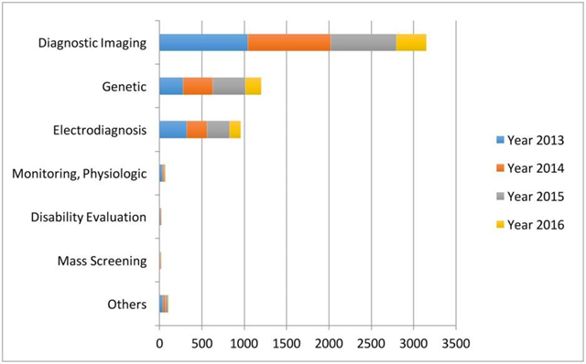

Figure ‎2‑1 The data types considered in the AI literature. The comparison is obtained through searching the diagnosis techniques in the AI literature on the PubMed database.

## Related Work to Brain Tumor Diagnosis Methods and Techniques

Fuyong Xing et al. presented the HySIME algorithm initial filtering by deep CNN followed by iterative region merging segmentation by a selective sparse shape model [45]. It has advantages of reduction of computing time, suitability for real-time applications. Their presented algorithm achieved an accuracy of 85% and a sensitivity of 89%. HT. Zaw et al. used morphological operations, pixel subtraction, and maximum entropy threshold segmentation in order to make segmentation pre-processing for improving the diagnostic performance of the human-machine combination using the available brain tumor MRI dataset [46]. However, the authors used morphological, and intensity as features with Naive Bayes classifier, and achieved an accuracy of 94 %.

TL. Narayana, and TS. Reddy presented a median filter GA segmentation algorithm for the segmentation process [47]. However, the authors the GLCM matrix elements as features with SVM classifier for the Harvard medical dataset and achieved an accuracy of 91.23%. A. Minz, and C. Mahobiya used median filter noise removal and threshold-based segmentation in order to image segmentation for improving the diagnostic performance of the human-machine combination using available public brain tumor MRI dataset [48]. However, this paper achieved only an accuracy of 89.90 %.

Astina Minz and Chndrakant Mahobiya presented an algorithm for brain tumor detection. This algorithm minimizes the detection error with less time consumption. Moreover, it maximizes the margin with respect to features that have already been select-ed [49]. This algorithm achieved a maximum accuracy of 89.90%. AR. Raju et al. used Bays scan fuzzy clustering segmentation, information theoretic scatters and wavelet features for pre-processing for COVID-19 detection [50]. Bayesian HCS-based multi-SVNN classifier has been used for brain tumor detection. It reported a 93% for accuracy.

Sindhumol S et al. introduced a method to enhance the classification of brain tumors from MRI based on spectral angle depending on feature extraction and Spectral Clustering Independent Component Analysis (SCICA) [51]. First the MR image is classified in to various clusters by spectral distance depending on clustering. Independent Component Analysis (ICA) is made on the clustered data along with SVM. Both, T1 weighted and T2 weighted and proton density fluid inversion recovery images have been used for rating. Comparative analysis has been made with ICA based on SVM and other conventional classifiers to achieve the stability and efficiency of SC-ICA based classification. The accuracy obtained by the analysis of ICA based on SVM results in 98% and 96.1% for reproduced lesions.

Sumitra and Saxena presented an NN method for the classification of MR brain images [52]. This method has 3 steps: feature extraction, dimensionality reduction and classification. Firstly, the feature extraction is made using PCA on MR images. Essential features such as mean, median, variance, correlation values of maximum and minimum intensity are extracted. The classification stage depends on back propagation. The classi-fier distinguishes the normal, benign and malignant cases. The results illustrate that the BPN classifier provides fast and more accurate classification than any other NN classifier. The classification accuracy of the testing dataset of the brain image is 73%.

Jafari and Shafaghi presented a hybrid method for the classification of brain tumors from MRI datasets based on GA and an SVM [53]. Their system contains four stag-es. In the first pre-processing stage, noise removal and contrast enhancement are made. In the second stage, segmentation is performed. Skull stripping is made with morphological operations. Then, in the third stage feature extraction and selection are performed. Feature selection is made depending on 4-class static features extracted from Fourier and wavelet transforms. Feature selection is made by means of GA optimization. Finally in the fourth stage, the selected features are fed as input to the SVM classifier to detect normal and abnormal cases with an accuracy of 83.22%.

Jayachandran and Dhanasekharan presented a method based on a hybrid algorithm for detection of brain tumors from MR images using statistical and SVM classifiers [54]. This method includes four stages called noise reduction, feature extraction, feature reduction and classification. Firstly, an anisotropic filter is applied for noise reduction to prepare the image for extracting features. After that, texture features are extracted using gray level co-occurrence matrix. Then, the number of extracted features is reduced using PCA. Finally, the FSVM classifier is used to classify the image as a normal or an abnormal image. The classification accuracy is about 95.80%.

Astina Minz, and Chandrakant Mahobiya presented an effective automatic classification method for brain MRI tumor detection [55]. The extracted features are projected using the Adaboost ML algorithm [55]. The presented method consists of three stages: pre-processing, feature extraction and classification. Pre-processing removes noise in the raw data. It transforms RGB image into grayscale. Hence, median filtering and threshold segmentation are applied. In the feature extraction using GLCM technique, 22 features are extracted from the MR image. The classification boosting technique is implemented using Adaboost. It gives an 89.90% accuracy, and results in normal brain, malignant or benign tumor.

Garima Singh, and M.A. Ansari provided a modern technique, which contains normalization of histograms and K-means Segmentation [56]. At first, the input image is pre-processed in order to remove the unwanted signals or noise. Filters such as median filter, adaptive filter, averaging filter, un-sharp masking filter and Gaussian filter are used on the MR images. In addition, the histogram of the pre-processed image is normalized and the classification of MR images is made. Finally, the image is segmented using K-means algorithm in order to localize the tumor in the MR image. Efficient classification of the MR images is done using NB and SVM classifiers for providing an accurate prediction and classification. The NB and SVM classifiers provide accuracies of 87.23% and 91.49%, respectively. The SVM classifier gives a better classification accuracy. Unfortunately, this technique could not find out precise boundaries of tumor regions.

Table ‎2‑1 Comparison study of the accuracy for the proposed models with the recently used techniques.

|  |  |  |
| --- | --- | --- |
| Model | Task | Accuracy |
| Sindhumol S. et al, 2013 [7] | Tumor and Normal | 98% for SVM |
| Sumitra, Saxena. 2013 [8] | Tumor and Normal | 73% |
| Mehdi Jafari, Reza Shafaghi. 2012 [9] | Tumor and Normal | 83.22% |
| Jayachandran. A, R. Dhanasekaran. 2013 [10] | Tumor and Normal | 95.80% |
| Fuyong Xing et al, 2016 [25] | Tumor and Normal | 85% |
| HT. Zaw et al, 2019 [26] | Tumor and Normal | 94 % |
| TL. Narayana, TS. Reddy 2018 [27] | Tumor and Normal | 91.23% |
| A. Minz, C. Mahobiya. 2017 [28] | Tumor and Normal | 89.90% |
| Astina Minz, Chndrakant Mahobiya 2017 [29] | Tumor and Normal | 89.90% & 74.00% |
| AR. Raju et al, 2018 [30] | Tumor and Normal | 93% |
| E. Sert et al, 2019 [31] | Tumor and Normal | 95% |
| S. Deepak, PM. Ameer 2019 [32] | Tumor and Normal | 97.8% & 98% |
| G. Hemanth et al, 2019 [33] | Tumor and Normal | 91% |
| PK. Mallick et al, 2019 [34] | Tumor and Normal | 96% |
| A. Selvapandian, K. Manivannan 2018 [35] | Tumor and Normal | 98.5% |
| HEM. Abdalla, MY. Esmail 2018 [36] | Tumor and Normal | 99% |
| AK. Anaraki et al, 2019 [37] | Tumor and Normal | 96% |
| J. Amin et al, 2017 [38] | Tumor and Normal | 98% |
| N. Gupta, P. Khanna 2017 [39] | Tumor and Normal | 98% |

## Summary

In this chapter, the key concepts related to AI techniques in healthcare applications including brain tumor detection are summarized. This chapter started with an overview of the history of AI techniques in healthcare application, then introduced biomedical signals. In particular, the different types of biomedical signals are discussed. Furthermore, a various AI technique for brain tumor diagnosis were introduced. Finally, the results of the study are discussed. These results indicated that the DL Techniques has the best detection performance, and the large databases gives a high performance.

# Deep Learning for Brain Tumor Detection

## Introduction

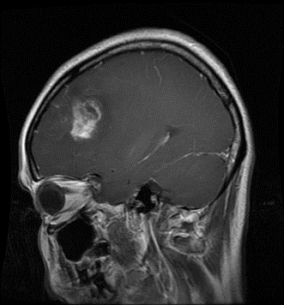In this chapter, proposed models for BRAIN TUMOR detection is presented. The main idea of the proposed models is to help the specialists for BRAIN TUMOR diagnosis as faster as possible from the MR images as shown in Figure 3.1. these models are based on deep CNN architecture. Different DL classification models are investigated on the dataset. Actually, we use a different 26 transfer learning model based on pretrained CNN models: EfficientNetB0, EfficientNetB1, EfficientNetB2, EfficientNetB3, Efficient-NetB4, EfficientNetB5, EfficientNetB7, Xception, VGG16, VGG19, ResNet50, Res-Net101, ResNet152, ResNet50V2, ResNet101V2, ResNet152V2, InceptionV3, Incep-tionResNetV2, MobileNet, MobileNetV2, DenseNet121, DenseNet169, DenseNet201, NASNetMobile, NASNetLarge. Also, this chapter gives a brief discussion about the different Deep Learning models used in this project. Also, provides the evaluation metrices results.

Figure ‎3‑1 Samples of MR images used to test the proposed models

## Proposed Models illustration

The proposed models are based on Pretrained Deep CNN architecture for classification of MR images. A general framework is applied for discrimination between three BRAIN TUMOR types and healthy MR cases.

## The Proposed CNN Models Architecture

The CNN is a DNN for image classification and the most established performing element of DL. It can extract features automatically from the provided training dataset to do the required tasks such as image classification. It achieves higher performance for the feature extraction process. The deep features are extracted from Conv and pooling layers and fed to the classifier for the training purpose. The feature extraction of the CNN is performed by the Conv layer and the pooling layer. The images are treated in the Conv layer by using a convolution operation, and the pooling layer reduces the image size. The deep features obtained from each CNN are used by soft-max function to take the decision. After that, the classification is performed, and the performance of the classification model is measured.

The proposed deep CNN model architecture used is shown in Figure 3.10. Generally, a CNN model includes many layers, which are input layer, Conv layers, pooling layers, FC layers, and output layer. The proposed CNN model has the following architecture:

• Input layer: The inputs are X-Ray images with image dimensions of 244 × 244.

• COVN layers: They are three layers: Conv, BN and ReLU layers. Conv layer is used to capture the features of the entire image and compress them into feature maps. Hence, we perform three convolutions over the input images using multiple filters (8, 16, 32, 64 and 128) for the first, second, third, fourth and fifth Conv, respectively, with a fixed widow size of 3. The BN layers are used for optimization in order to reduce the overfitting and obtain better test accuracy. The activations of the previous layer for each batch during training is normalized. ReLU activation functions are used to incorporate element-wise nonlinearity.

• Pooling layer: It is used to extract the most applicable features within each feature map. We use the max-pooling strategy for the pooling operation. All vectors that are obtained from the max-pooling layer are used to obtain a fixed-length feature vector. The max pooling is set to 2 × 2 with a stride of 2.

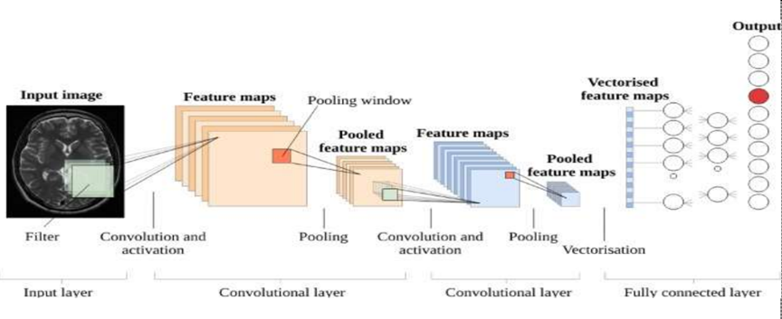• FC layer: It treats its input data as a simple vector and produces an output as a single vector. We have 4 FC layers in the proposed model. The last one is an FC output layer with softmax activation for classifying the input images into two classes.

Figure ‎3‑2 The blocks diagram of the proposed method for the detection of brain tumor

## Performance Metrics

The performance of the proposed models is evaluated using standard measures such as sensitivity, accuracy, precision, and . The cross-validation estimator is implemented, and this results in a confusion matrix as illustrated in Table 1 [86].

Table ‎3‑1 Confusion matrix structure

|  |  |  |
| --- | --- | --- |
|  | **Predicted positive** | **Predicted negative** |
| **Actual positive** | True positive | False negative |
| **Actual negative** | False positive | True negative |

The confusion matrix has foursome expected outcomes as follows. True positive () is the number of correctly diagnosed anomalous cases. True negative () is the number of correctly identified normal cases. False positive () is a set of normal cases, which are classified as anomaly diagnoses. False negative () is a set of anomalies observed as normal.

The overall performance analysis for each DL classifier will be evaluated based on Sen, Spec, Accuracy, Precision and F1 score [90, 91].

Recall or Sensitivity is given by:

Accuracy is given by:

Precision is given as:

is given by:

## Summary

With the spreading of brain tumor pandemic, artificial intelligence tools have found applications in the automated diagnosis of brain tumor cases. In the proposed models, the detection of brain tumor cases from MR images has been investigated with different classifiers. The results have proved success of detection. Moreover, the recommended models for detection are 20 Transfer Learning models. The higher performance of these classifiers reduces overfitting problem also reduces the variance and therefore improves the accuracy. Simulation results proved that the four-state scenario comprising for brain tumor-normal, brain tumor types is achieving higher accuracies. We can consider the proposed models as an efficient tool for the classification of brain tumor cases.

# Image Processing for Brain Tumor

## Introduction

The proposed machine learning framework is tested on the dataset of MRI brain tumor. The MR images brain tumor dataset contains 826 MR images for glioma tumor, 822 MR images for meningioma tumor, 827 MR images for pituitary tumor and 835 MR images for normal cases [19].The [dataset](https://www.kaggle.com/sartajbhuvaji/brain-tumor-classification-mri.) that used to test the model.[19]

## Image Super Resolution

* The goal is too upscale and improve the quality of low-resolution images.
* for that, we use ISR library which contains Keras implementations of different Residual Dense Networks for Single Image Super-Resolution (ISR) as well as scripts to train these networks using content and adversarial loss components.
* The implemented networks include:
  + The super-scaling Residual Dense Network described in Residual Dense Network for Image Super-Resolution (Zhang et al. 2018)
  + The super-scaling Residual in Residual Dense Network described in ESRGAN: Enhanced Super-Resolution Generative Adversarial Networks (Wang et al. 2018)
  + A multi-output version of the Keras VGG19 network for deep features ex-traction used in the perceptual loss
  + A custom discriminator network based on the one described in Photo-Realistic Single Image Super-Resolution Using a Generative Adversarial Network (SRGANS, Ledig et al. 2017)

### RDN Pre-trained weights

The weights of the RDN network trained on the DIV2K dataset are available in weights/sample_weights/rdn-C6-D20-G64-G064-x2/PSNR-driven/rdn-C6-D20-G64-G064-x2_PSNR_epoch086.hdf5. The model was trained using C=6, D=20, G=64, G0=64 as parameters (see architecture for details) for 86 epochs of 1000 batches of 8 32x32 augmented patches taken from LR images.

### RDN Network architecture

The main parameters of the architecture structure are:

* D - number of Residual Dense Blocks (RDB)
* C - number of convolutional layers stacked inside a RDB
* G - number of feature maps of each convolutional layers inside the RDBs
* G0 - number of feature maps for convolutions outside of RDBs and of each RBD output.

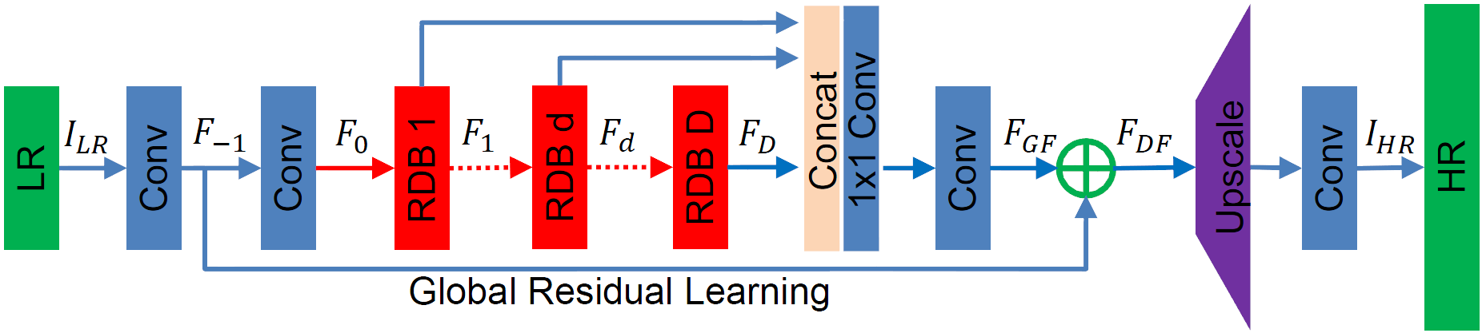

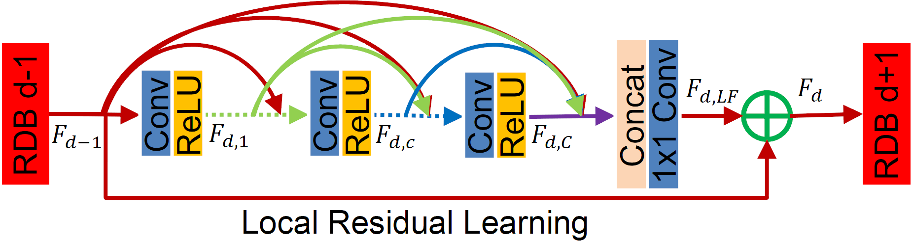

Figure ‎4‑1 Residual Dense Network for Image Super-Resolution

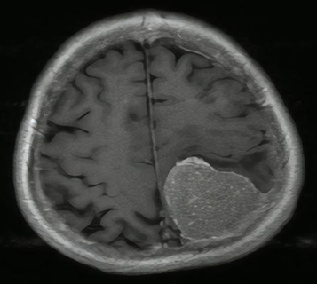

Figure ‎4‑2 Before applying Super Resolution

Figure ‎4‑3 After applying Super Resolution

## Image Segmentation

* Segmentation is the process of splitting an image into separate objects.
* Brain tumor localization and segmentation from magnetic resonance imaging (MRI) are hard and important tasks for several applications in the field of medical analysis. As each brain imaging modality gives unique and key details related to each part of the tumor.
* For these MRI data, tumor area has high-intensity values. So, one approach is to take the original image, filter it to reduce noise and smooth edges.
* then mask it to select pixels with relatively high values.

### A close-up of a mri scan Description automatically generated with low confidenceProcedures

Figure ‎4‑4 Brain Tumor image

1. First, Plotting the histogram of image to shows intensities of pixels.
2. then, we'll create the mask by applying a small Gaussian filter, then masking pixels with intensities lower than 95.
3. A black and white image of the earth

   Description automatically generated with medium confidenceNext, we "label" the mask. The labelling algorithm treats 0 values as back-ground pixels, and then it looks for all of the objects that are separated by background.

Figure ‎4‑5 After applying mask

1. Chart

   Description automatically generated with medium confidenceIt then returns an array where each object has been indexed, as well as the number of objects detected.

Figure ‎4‑6 Labelled image

1. It seems we have 96 distinct objects in this image.
2. 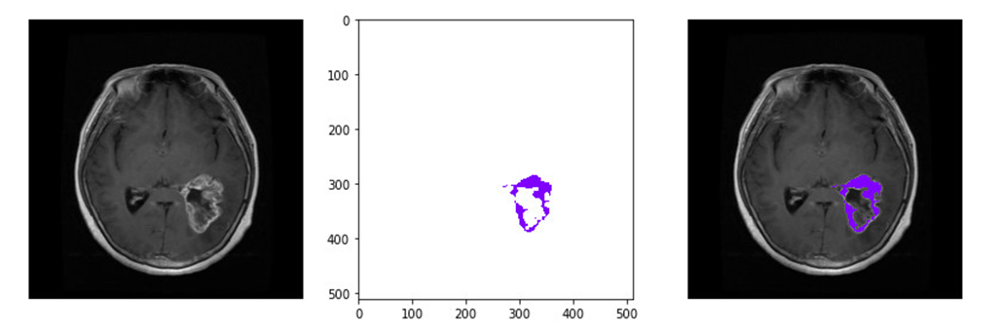Plotting the labels with the rainbow colormap shows that the tumor has been assigned a unique label value.

Figure ‎4‑7 locate the tumor in brain

# Hyper-Tuning & Results

## Hyper parameters tuning

There is a lot of hyper parameters in MLP that should be tune such as the number of hidden layers sizes, learning rate, solver and max iterations. In addition, there’s a lot of strategies to consider and two generic approaches to parameter search are provided in scikit-learn for given values: GridSearchCV and RandomizedSearchCV.

### Grid Search

It can be thought of as an exhaustive search for selecting a model. In Grid Search, the data scientist sets up a grid of hyper parameter values and for each combination, trains a model and scores on the testing data. In this approach, every combination of hyper parameter values is tried which can be very inefficient. For example, searching 20 different parameter values for each of 4 parameters will require 160,000 trials of cross-validation. This equates to 1,600,000 model fits and 1,600,000 predictions if 10-fold cross validation is used. While Scikit Learn offers the GridSearchCV function to simplify the process, it would be an extremely costly execution both in computing power and time.

### Random Search

By contrast, sets up a grid of hyper parameter values and selects random combinations to train the model and score. This allows you to explicitly control the number of parameter combinations that are attempted. The number of search iterations is set based on time or resources. Scikit Learn offers the RandomizedSearchCV function for this process.

While it’s possible that RandomizedSearchCV will not find as accurate of a result as GridSearchCV, it surprisingly picks the best result more often than not and in a fraction of the time it takes GridSearchCV would have taken. Given the same resources, Randomized Search can even outperform Grid Search. To choose the best hyper parameters to maximize the general performance we will test our model using cross validation method.

### Cross-validation

Cross validation is a statistical method used to estimate the performance (or accuracy) of machine learning models. It is used to protect against overfitting in a predictive model, particularly in a case where the amount of data may be limited. In cross-validation, you make a fixed number of folds (or partitions) of the data, run the analysis on each fold, and then average the overall error estimate.

## Results

### A picture containing graphical user interface Description automatically generatedEfficientNetB0

Figure ‎5‑1 EfficientNetB0 results

### EfficientNetB1

Figure ‎5‑2 EfficientNetB1 results

### EfficientNetB2

**

Figure ‎5‑3 EfficientNetB2 results

### InceptionResNetV2

Figure ‎5‑4 InceptionResNetV2 results

### InceptionV3

Figure ‎5‑5 InceptionV3 results

### ResNet50

Figure ‎5‑6 ResNet50 results

### ResNet101 - V2

Figure ‎5‑7 ResNet101 - V2

### Xception

**

Figure ‑8 Xception

# Conclusion and Future Work

The main reason behind the utilization of AI techniques in healthcare applications is to achieve an accurate end-to-end for diseases diagnosis, therefore, the improvement of diseases diagnosis systems efficiency may be achieved by using different AI techniques. Therefore, to help a doctor overcome diseases diagnosis limitations, in this thesis, three different diseases are presented and discussed with many different AI techniques that are used for diseases diagnosis.

## Conclusion

1. Best model to get a validation accuracy is EfficientNetB0 with accuracy 98.503%.​
2. Data augmentation improve accuracy of model.​
3. Image processing techniques such as super resolution will slightly increase the performance of the Brain tumor diagnosis models.​
4. Result and efficiency according to previous work and researches was very good.​

## Future Work

1. Integrate segmentation with API.​
2. Working on Larger Datasets with different types of medical images.
3. Create Systems will be made more Noise-Robust in the Future.​
4. Detect more than 3 types of tumors (total 130 types).​
5. Implement the project using FPGA and use it in hospitals.​

References

[1]. S. Bauer et al., ―A survey of MRI-based medical image analysis for brain tumor studies,Phys. Med. Biol., vol. 58, no. 13, pp.97–129, 2013.

[2]. B. Menze et al., ―The multimodal brain tumor image segmentation benchmark (BRATS),IEEE Trans. Med. Imag., vol. 34, no.10, pp. 1993–2024, Oct. 2015

[3]. B. H. Menze et al., ―A generative model for brain tumor segmentation in multi-modal images, in Medical Image Computing and Comput.- Assisted Intervention-MICCAI 2010. New York: Springer, 2010, pp. 151–159

[4]. S. Bauer, L.-P. Nolte, and M. Reyes, ―Fully automatic segmentation of brain tumor images using support vector machine classification in combination with hierarchical conditional random field regularization,‖ in Medical Image Computing and Comput.-Assisted Intervention-MICCAI 2011. New York: Springer, 2011, pp. 354–361.

[5]. C.-H. Lee et al., ―Segmenting brain tumors using pseudo-conditional random fields, in Medical Image Computing and Comput.-Assisted

[6]. Intervention-MICCAI 2008. New York: Springer, 2008, pp. 359–366

[7]. R. Meier et al., ―A hybrid model for multimodal brain tumor segmentation,‖ in Proc. NCIMICCAI BRATS, 2013, pp. 31–37.

[8]. Vinod Kumar, JainySachdeva, Indra Gupta ―Classification of brain tumors using PCAANN‖ 2011 World Congress on Information and Communication Technologies

[9]. Sergio Pereira, Adriano Pinto, Victor Alves, and Carlos A. Silva ―Brain Tumor Segmentation Using Convolutional Neural Networks in MRI Images‖IEEE TRANSACTIONS ON MEDICAL IMAGING, VOL. 35, NO. 5, MAY 2016

[10]. RaselAhmmed, Md. Foisal Hossain ―Tumor Detection in Brain MRI Image Using Template based K-means and Fuzzy C-means Clustering Algorithm‖ 2016 International Conference on Computer Communication and Informatics (ICCCI -2016), Jan. 07 –09, 2016,Coimbatore, INDIA

[11]. S.C. Turaga, J.F. Murray, V. Jain, F. Roth, M. Helmstaedter, K. Briggman,W. Denk, andH.S. Seung. Convolutional networks can learn to generate affinity graphs for image segmentation. Neural Computation, 22(2):511–538, 2010

[12] A Reliable Method for Brain Tumor Detection Using Cnn Technique NeethuOuseph C1,Asst. Prof. Mrs.Shruti K2 1(Digital electronics ECE, Malabar Institute of Technology, India)

[13] B. H. Menze, A. Jakab, S. Bauer, J. Kalpathy-Cramer, K. Farahani, J. Kirby, et al. "The Multimodal Brain Tumor Image Segmentation Benchmark (BRATS)", IEEE Transactions on Medical Imaging 34(10), 1993-2024 (2015) DOI: 10.1109/TMI.2014.2377694

[14] S. Bakas, H. Akbari, A. Sotiras, M. Bilello, M. Rozycki, J.S. Kirby, et al., "Advancing The Cancer Genome Atlas glioma MRI collections with expert segmentation labels and radiomic features", Nature Scientific Data, 4:170117 (2017) DOI: 10.1038/sdata.2017.117

[15] S. Bakas, M. Reyes, A. Jakab, S. Bauer, M. Rempfler, A. Crimi, et al., "Identifying the Best Machine Learning Algorithms for Brain Tumor Segmentation, Progression Assessment, and Overall Survival Prediction in the BRATS Challenge", arXiv preprint arXiv:1811.02629 (2018)

[16]A.Vidyarthi, N.Mittal, ―CLAP: Closely link associated pixel based extraction of brain tumor in MR images‖, International Advance Computing Conference on Signal Processing and Communication (IACC), pp. 202 -206

[17] International Journal of Computer Science and communication Vol. 2, No. 2, JulyDecember-2011,pp. 325-331

[18] k. Ramya and L. K. Joshila Grace ―Brain tumor detection based on watershed transformation‖, International Conference on Communication and Signal Processing (ICCSP),2016.

[19]Luxit Kapoor and Sanjeev Thakur ―A survey on brain tumor detection using Imageprocessing techniques‖,7s International Conference on Cloud Computing, Data Science &Engineering-Confluence, 2017.

[20] MinuSamantaray ,MilleePanigrahi, K.C .Patra ,AvipsaS.Panda and Rina Mahakud ―An adaptive filtering technique filtering technique for brain tumor analysis and detection‖,10th International Conference on Intellligent and Control (ISCO),2016.

[21] S.U. Aswathy, G.Glan Deva Dhas and S.S. Kumar ―A Survey on detection of brain tumor from MRI Brain images‖, 7th International Conference on Cloud Computing, Data Science &Engineering –Confluence 2017.

[22] S. Banerjee, S. Mitra, and B. U. Shankar, ―Synergetic neuro-fuzzy feature selection and classification of brain tumors, in 2017 IEEE International Conference on Fuzzy Systems (FUZZ-IEEE), 2017, pp.1–6.